Mathematics Specialist Unit 3

Test 2: Polynomials and Functions

**Student Name:** _______________________________________

**Time allowed for this task:** 55 minutes, in class, under test conditions

Section One – calculator-free section 22 minutes (21 marks)

Section Two – calculator-assumed section 33 minutes (32 marks)

**Materials required:** Calculator with CAS capability (to be provided by the student)

Standard items: Pens (blue/black preferred), pencils (including coloured), sharpener, correction fluid/tape, eraser, ruler, highlights

Special items: Drawing instruments, templates, and up to three calculators approved for use in WACE examinations.

One page of A4 notes, written on both sides.

Mathematics Specialist formulae sheet.

**Marks available:** 53 marks

**Task weighting: 7%**

**Section One – calculator-free section**

**No calculators or notes are to be used.**

**Access to approved Mathematics Specialist formulae sheet is permitted.**

Simplify answers where possible.

**Question 1. (4 marks)**

If $f\left(x\right)=x^{2}+1$ and $g\left(x\right)=$ $\frac{2}{x}$ find the natural domain and corresponding range for

1. fog(x) (2)
2. gof(x) (2)

**Question 2. (4 marks)**

Find an expression for the inverse function of $h$ where $h\left(x\right)=1+$ $\frac{1}{3+x}$ and state the domain and range of $h^{-1}$.

**Question 3. (2 marks)**

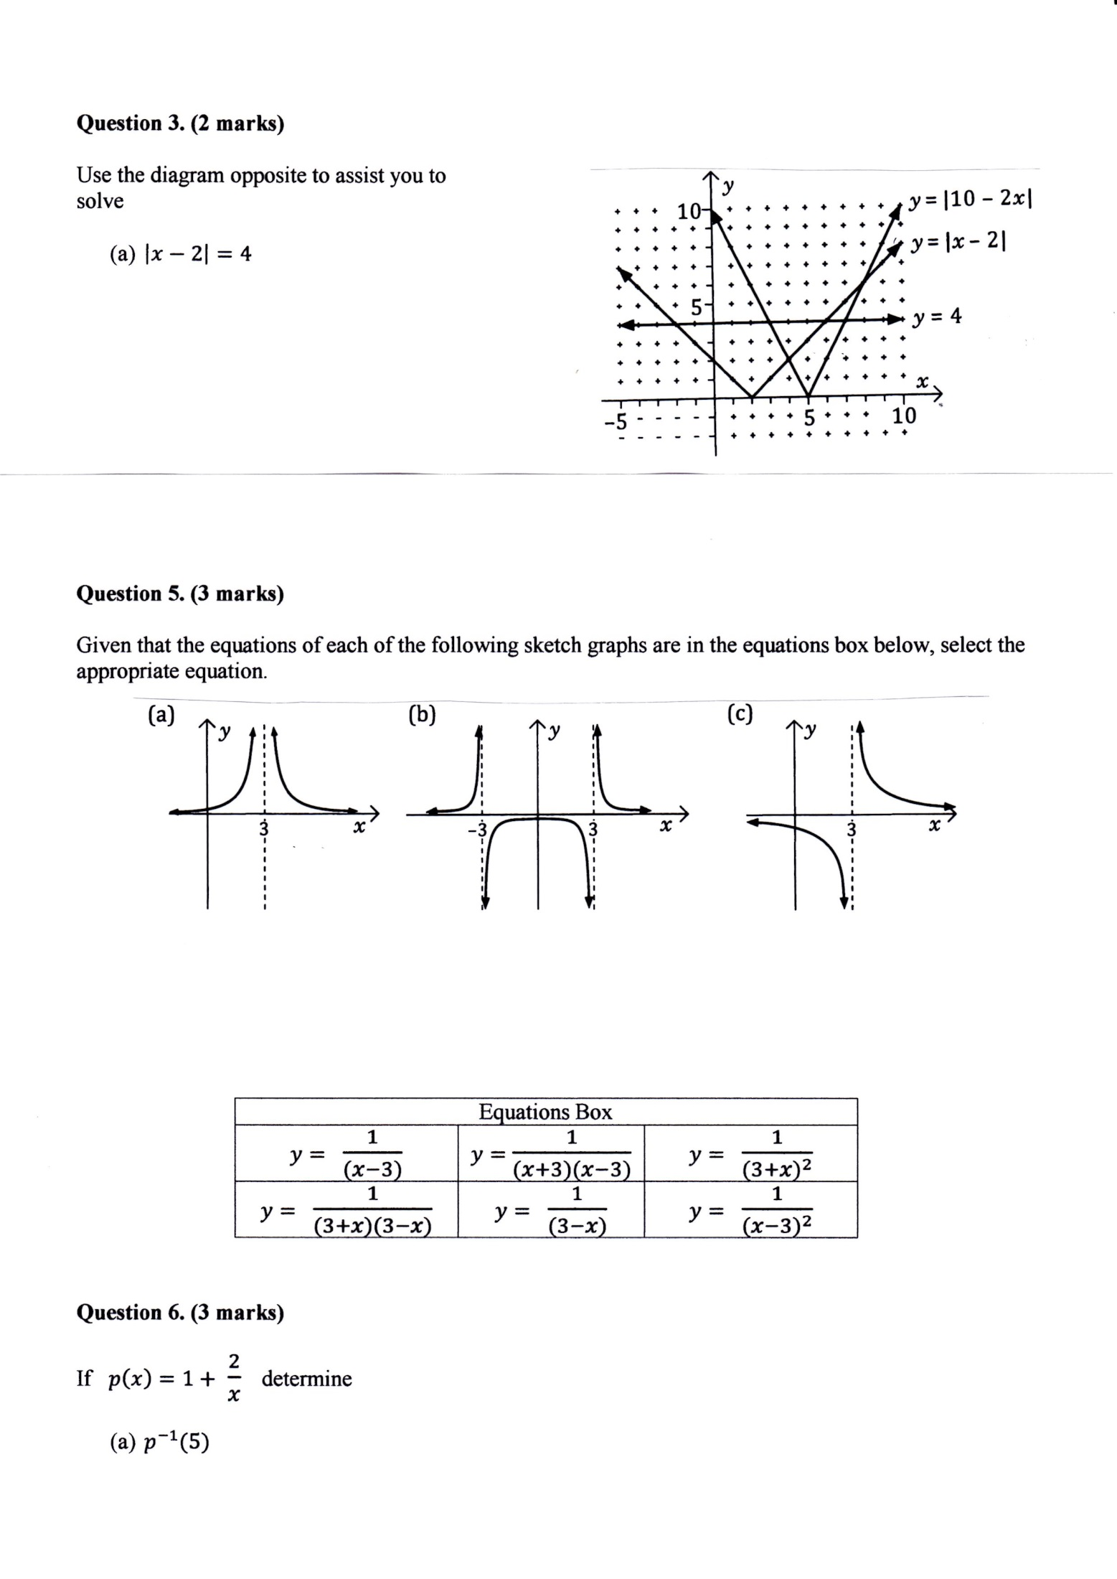Use the diagram opposite to assist you to solve:

$\left|x-2\right|=4$

$\left|10-2x\right|=\left|x-2\right|$

**Question 4. (4 marks)**

Consider the nature of the graph of $y=$ $\frac{x^{2}-3x-4}{x^{3}-2x^{2}-3x}$. Describe the effect on the y values of the

graph as

1. x tends to $+∞$
2. x tends to $3^{+}$
3. x tends to $-1^{-}$
4. x tends to $4^{-}$

**Question 5. (3 marks)**

The graph of $y=-2\left|x-4\right|+6$ is shown below. Find $a, b$ and $c$ such that the solution to the equation

$-2\left|x-4\right|+6=a\left|x+b\right|+c$ is $4≤x≤6$.

*y*

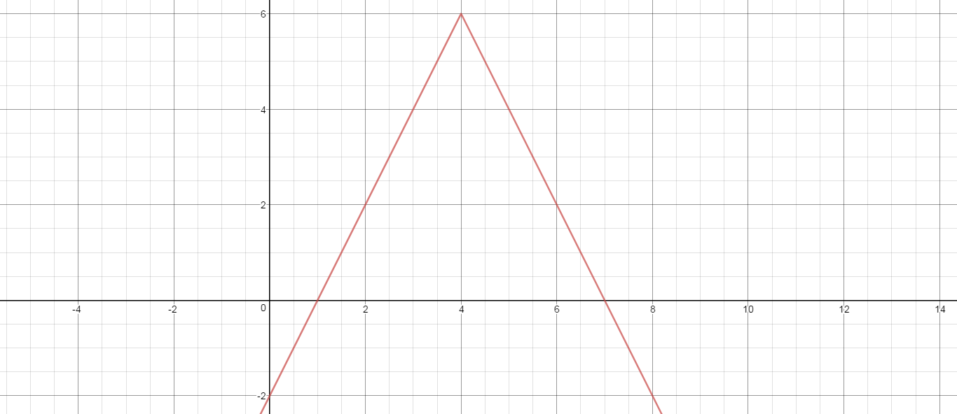

*x*

**Question 6. (4 marks)**

If $p\left(x\right)=1+$ $\frac{2}{x}$ determine

1. $p^{-1}(5)$ (2)
2. The value(s) of x such that $p^{-1}(x)=p(x)$. (2)

**End of Section One**

**This page has intentionally been left blank.**

You may use this space to extend your working on a particular question or questions. Remember to number each extension.

**Do not turn over the page until so directed.**

**Section Two – calculator-assumed section**

**Calculators and 1 page of A4 notes, written on both sides, allowed.**

**Access to approved Mathematics Specialist formulae sheet is permitted.**

**Question 7. (4 marks)**

The graph of $y=p(x)$ is shown twice below. In diagram (a) show the graph of $y=p(\left|x\right|)$ while in diagram (b) show the graph of $y=\left|p(x)\right|$.

(a) *y* (b) *y*

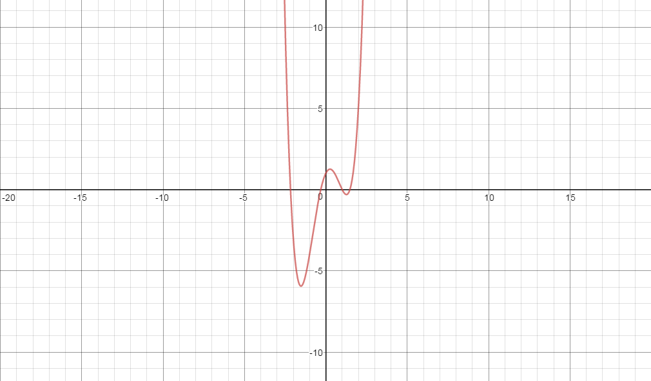

*x x*

**Question 8. (3 marks)**

Find an expression for the inverse function of $f(x)$ where $f\left(x\right)=4+$ $\frac{2}{2x-1}$ and state its

domain and range.

**Question 9. (4 marks)**

Given that $p\left(x\right)=x^{2}-4$ and $q\left(x\right)=$ $\frac{1}{x}$ state the natural domain and the corresponding

range of each of the following functions:

1. $poq(x)$ (2)
2. $qop(x)$ (2)

**Question 10. (6 marks)**

Determine all of the asymptotes for each of the following functions:

1. T(x) = $\frac{x^{2}+3x}{x-1}$ (2)
2. U(x) = $\frac{x^{2}-9}{x(x+3)}$ (2)
3. V(x) = $\frac{x^{2}+1}{(2x-1)(x+2)}$ (2)

**Question 11. (4 marks)**

Consider the graph of $y=$ $\frac{x^{2}+x-2}{x^{3}-2x^{2}-x+2}$.

1. Locate any asymptotes. (2)
2. Describe any other discontinuities. (2)

**Question 12. (5 marks)**

The graph of $y=f(x)$ is shown below. It has asymptotes at $x=2, x=6, y=-\frac{1}{2}$. On the same set of axes draw the graph of $y=$ $\frac{1}{f(x)}$, clearly showing any roots and asymptotes.

*y*

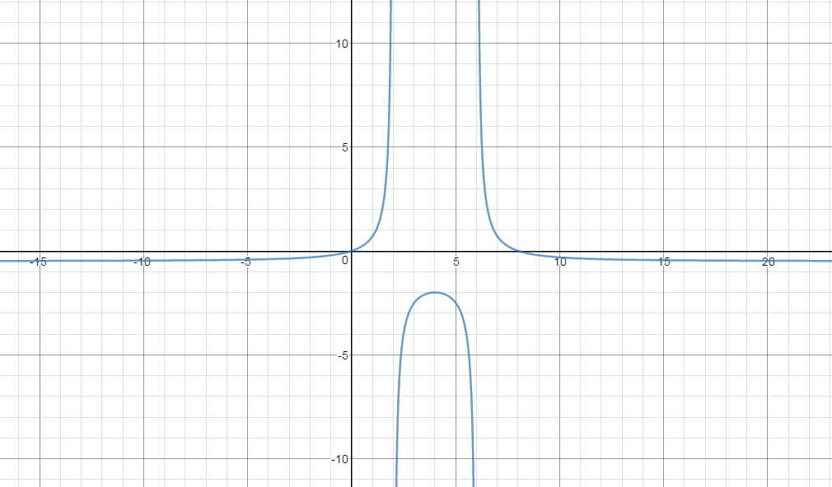

*x*

**Question 13. (6 marks)**

The graph of $g\left(x\right)=$ $\frac{(x-4)(x-1)}{x-2}$, $x<2$ is shown below:

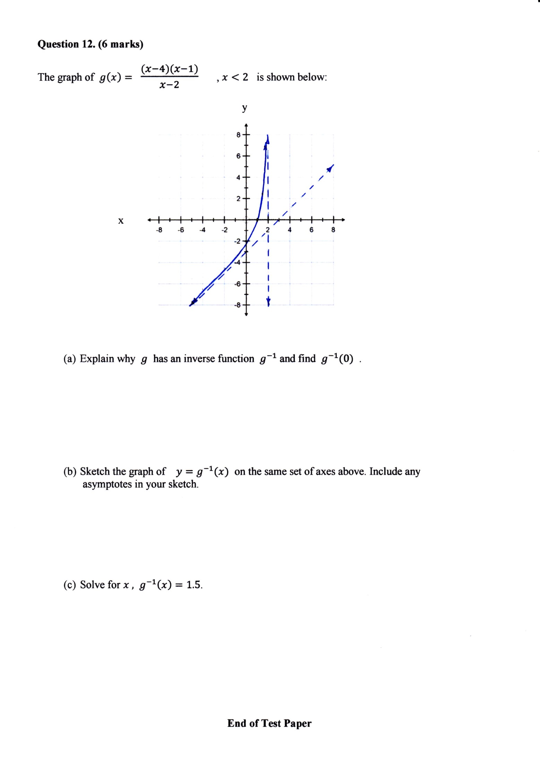

1. Explain why $g$ has an inverse function $g^{-1}$ and find $g^{-1}(0)$. (2)
2. Sketch the graph of $y=g^{-1}(x)$ on the same set of axes above. Include any

asymptotes in your sketch. (2)

1. Solve for $x ,$ $g^{-1}\left(x\right)=1.5$. (2)

**End of Test Paper**

**This page has intentionally been left blank.**

You may use this space to extend your working on a particular question or questions. Remember to number each extension.